# Appendix -3: Facility Numbers

| **#** | **Program Title** | **Submitting Hospital** | **Facility Number** |
| --- | --- | --- | --- |
| 4 | Neuroendocrine | London Health Sciences | 936 |
| Hamilton Health Sciences Corporation | 942 |
| University Health Network | 947 |
| Sunnybrook Health Sciences Centre | 953 |

# Appendix-11: Valid 2-digits Postal Codes

(Source: Cancer Care Ontario's Data Book - 2012-2013, Appendix B - Province and State codes, at link https://www.cancercare.on.ca/ext/databook/db1213/databook.htm).

The table below provides list of valid 2 digit postal codes for province and State codes.

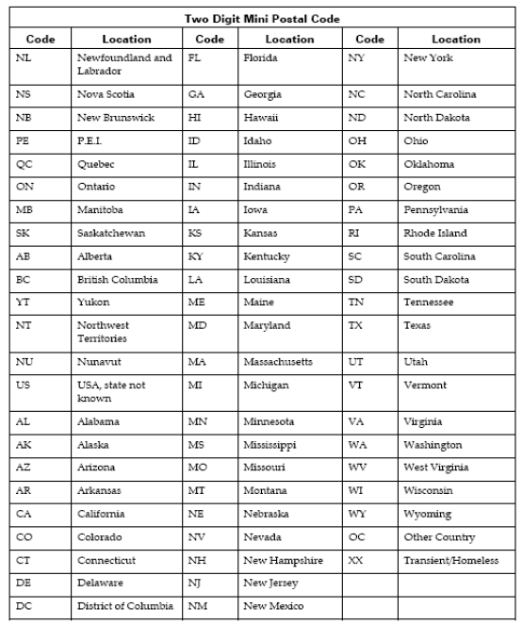

# Appendix-20: Morphology Codes

This is a complete listing of valid Morphology codes and includes the new Haematopoietic codes effective January 2010.

Citation for new classification:

WHO Classification of Tumours of Haematopoietic and Lymphoid Tissues, 4th ed., edited by S. H. Swerdlow, et al., International Agency for Research on Cancer, Lyon, 2008. ISBN 978-92-832-2431-0

(For details, please refer Cancer Care Ontario's Data Book - 2012-2013, Appendix 1.36 - Morphology Codes, at link https://www.cancercare.on.ca/ext/databook/db1213/databook.htm)

# Appendix-21: ICDO-3 Topography with Laterality

This is a table of topography codes where laterality is applied as stipulated in the FORDS manual.

(For details, please refer Cancer Care Ontario's Data Book - 2012-2013, Appendix 1.3 ICDO-3 TOPOGRAPHY with Laterality, at link https://www.cancercare.on.ca/ext/databook/db1213/databook.htm)

# Appendix-22: Pharmaceutical dose unit

This table provides info for Radio pharmaceutical dose unit

| **Unit Code** | **Description** |
| --- | --- |
| cap | capsule |
| MBq | megabecquerels |
| mcg | microgram |
| mEq | milliequivalent |
| MU | million units |
| tab | tablet |
| unit | unit |
| mg | milligram |
| mL | milliliter |
| drop | drop |
| pfu | plaque forming unit |
| cm | centimeter |
| g | gram |
| loz | lozenge |
| mmol | millimoles |
| part | particle |
| ptch | patch |
| pkt | packet |
| pop | popsicle |
| puff | puff |
| spry | spray |
| supp | suppository |